CARIBBEAN MILITARY TECHNICAL TRAINING INSTITUTE
TIMBER ROOFER JOB CERTIFICATION
INFORMATION SHEET

Instructor: Adrian Mendez
Date: April 8, 2024
Units: CRIWHS0013A: Comply with the occupational hygiene principles to manage WHS risks
BCGCOR1583D: Read and interpret building plans and specifications
BCGCAR0523B: Construct timber roof structures
BCGROF1553C: Install sheeting and cladding roofing materials
BCGROF1563B: Repair sheeting and cladding roofing materials
BCGCAR0473B: Erect timber roof trusses
BCGROF0683B: Tile a roof
BCGROF1493B: Fix shingles to roofs and facades
BCGCAR0793D: Erect ceiling framing

COMPLY WITH THE OCCUPATIONAL HYGIENE PRINCIPLES TO MANAGE WHS RISKS

WHAT IS OCCUPATIONAL HYGIENE?
Occupational Hygiene is the discipline of anticipating, recognizing, evaluating, and controlling health hazards in the working environment with the objective of protecting workers health and well-being and safeguarding the community at large.
Occupational hygiene, also known as industrial hygiene, involves the recognition, evaluation, and control of factors or stresses arising from the workplace that may cause sickness, impaired health, or significant discomfort among workers or the community. It encompasses a broad range of hazards, including chemical, biological, physical, and ergonomic factors.

IMPORTANCE OF OCCUPATIONAL HYGIENE
The significance of occupational hygiene lies in its role in safeguarding the health and well-being of workers. By identifying and mitigating workplace hazards, occupational hygiene helps prevent occupational diseases, injuries, and fatalities, thereby enhancing worker productivity and organizational efficiency. Moreover, it contributes to regulatory compliance, reputation management, and sustainability goals of organizations.

FUNDAMENTAL PRINCIPLES OF OCCUPATIONAL HYGIENE
Hazard Identification
The first step in managing WHS risks is identifying hazards present in the workplace. Hazards can arise from various sources, including chemical substances, biological agents, physical agents (e.g., noise, radiation), and ergonomic factors (e.g., repetitive motions, awkward postures). Conducting thorough hazard identification involves site inspections, data analysis, and consultation with workers to identify potential sources of harm.

Risk Assessment
Once hazards are identified, the next step is to assess the risks associated with these hazards. Risk assessment involves evaluating the likelihood and severity of harm that may result from exposure to specific hazards. This process may include quantitative risk assessment techniques, such as exposure monitoring and mathematical modeling, as well as qualitative assessments based on expert judgment and historical data.

Control Measures
Based on the findings of the risk assessment, control measures are implemented to eliminate or minimize workplace hazards. Control measures may include engineering controls (e.g., ventilation systems, isolation barriers), administrative controls (e.g., work practices, training programs), and personal protective equipment (PPE). The hierarchy of controls prioritizes the use of controls that eliminate or reduce hazards at the source before relying on measures that rely on human behavior or reliance on PPE.

COMMON WORKPLACE HAZARDS AND CONTROL MEASURES
Chemical Hazards
Chemical hazards are prevalent in many workplaces, including manufacturing facilities, laboratories, and construction sites. These hazards may arise from exposure to toxic substances, flammable materials, or corrosive agents. Control measures for chemical hazards include substitution of hazardous substances, engineering controls such as ventilation systems, administrative controls like safe handling procedures, and the use of PPE such as gloves and respirators.

Biological Hazards
Biological hazards encompass a wide range of organisms, including bacteria, viruses, fungi, and parasites, that can cause infectious diseases or allergic reactions in workers.
Control measures for biological hazards may include vaccination programs, hygiene practices (e.g., handwashing), disinfection protocols, and the use of personal protective equipment such as gloves and masks.

Physical Hazards
Physical hazards include factors such as noise, vibration, radiation, temperature extremes, and ergonomic stressors. Control measures for physical hazards may include engineering controls such as soundproofing, vibration isolation, shielding, and ergonomic workstation design. Administrative controls like job rotation, rest breaks, and training on proper lifting techniques are also essential for mitigating physical hazards.

Ergonomic Hazards
Ergonomic hazards result from factors that may cause musculoskeletal disorders or discomfort due to repetitive motions, awkward postures, or excessive force. Control measures for ergonomic hazards include ergonomic assessments of workstations, job redesign, training on proper lifting techniques, and the provision of ergonomic equipment such as adjustable chairs and ergonomic keyboards.

LEGAL AND ETHICAL CONSIDERATIONS
Regulatory Compliance
Compliance with occupational hygiene standards is not only a legal requirement but also an ethical obligation for employers to protect the health and safety of their workers. Regulatory agencies such as the Occupational Safety and Health Administration (OSHA) in the United States and the Health and Safety Executive (HSE) in the United Kingdom establish and enforce standards for workplace health and safety.

Duty of Care
Employers have a duty of care to provide a safe working environment for their employees, which includes identifying and controlling workplace hazards through effective risk management practices. Failure to comply with occupational hygiene standards may result in legal liabilities, fines, penalties, and reputational damage for organizations.

PROMOTING A CULTURE OF SAFETY
Education and Training
Education and training programs play a crucial role in promoting awareness and understanding of occupational hygiene principles among workers.
By providing comprehensive training on hazard recognition, risk assessment, and control measures, organizations can empower employees to contribute actively to WHS risk management efforts.

Communication
Effective communication is essential for fostering a culture of safety within organizations. Employers should ensure clear and transparent communication channels for reporting hazards, incidents, and near misses. Regular safety meetings, newsletters, and signage can help reinforce safety messages and promote a collective commitment to WHS.

INTEGRATION OF OCCUPATIONAL HYGIENE INTO WHS MANAGEMENT SYSTEMS
To effectively manage WHS risks, organizations must integrate occupational hygiene principles into their broader WHS management systems. This integration involves embedding occupational hygiene considerations into policies, procedures, and practices across all levels of the organization. Key strategies for integrating occupational hygiene into WHS management systems include:
- Leadership Commitment: Senior management commitment is essential for promoting a culture of safety and prioritizing occupational hygiene principles within the organization. Leaders should allocate resources, establish clear responsibilities, and actively participate in WHS initiatives to demonstrate their commitment to employee health and safety.

- Employee Involvement: Engaging employees in WHS decision-making processes fosters ownership and accountability for occupational hygiene practices. Workers should be encouraged to report hazards, participate in risk assessments, and provide feedback on control measures to ensure their perspectives are considered in WHS management.

- Training and Education: Providing comprehensive training and education programs on occupational hygiene principles equips employees with the knowledge and skills needed to identify hazards, assess risks, and implement control measures effectively. Training should be tailored to specific job roles and hazards present in the workplace.

- Risk Communication: Open and transparent communication channels facilitate the exchange of information regarding workplace hazards, control measures, and WHS policies. Clear communication helps raise awareness, build trust, and promote a collaborative approach to WHS risk management among employees, supervisors, and management.
- Continuous Improvement: WHS management systems should undergo regular review and evaluation to identify areas for improvement and ensure ongoing compliance with occupational hygiene principles. Organizations should establish mechanisms for collecting feedback, conducting audits, and implementing corrective actions to enhance WHS performance over time.

READ AND INTERPRET BUILDING PLANS AND SPECIFICATIONS
BUILDING PLANS
Building plans and specifications are the foundational documents that guide the construction process. They encapsulate the vision of architects, engineers, and designers, translating it into tangible structures. Understanding and interpreting these documents is essential for architects, engineers, contractors, and various stakeholders involved in the construction industry.
The plan doesn’t show any details of how the roof framing should be constructed. It is assumed that the carpenters constructing the roof framing will be competent tradespeople who know what they’re doing. The written specifications for the job will also state which standard is to be followed for each part of the building.

IMPORTANCE OF BUILDING PLANS AND SPECIFICATIONS
Building plans and specifications serve as the roadmap for construction projects. They outline every aspect of a building's design, from its layout and structural components to its electrical, plumbing, and mechanical systems. Without clear and accurate plans and specifications, construction projects are prone to errors, delays, and cost overruns. These documents provide common language for architects, engineers, contractors, and subcontractors, ensuring that everyone is on the same page throughout the construction process. Moreover, building plans and specifications are essential for obtaining permits, securing financing, and ensuring compliance with building codes and regulations.

COMPONENTS OF BUILDING PLANS
Building plans consist of several key components, each providing crucial information about the project. These components typically include:
- Site Plan: A site plan depicts the layout of the building on the site, including property lines, setbacks, landscaping, and access points.

- Floor Plans: Floor plans illustrate the layout of each floor of the building, showing the arrangement of rooms, walls, doors, windows, and other features.
- Elevations: Elevations are orthographic projections that show the exterior views of the building from all sides, providing details on its height, shape, and architectural features.

- Sections: Sections are vertical cutaway views that reveal the internal structure of the building, including the arrangement of floors, ceilings, walls, and structural elements.

- Details: Details provide specific information about construction elements, such as connections, materials, and finishes, ensuring accuracy and quality in the execution of the design.

TYPES OF BUILDING PLANS AND SPECIFICATIONS
Building plans and specifications can vary depending on the type and complexity of the project. Some common types include:
- Architectural Plans: Architectural plans focus on the overall design and layout of the building, including its aesthetics, spatial organization, and circulation.

- Structural Plans: Structural plans detail the structural components of the building, such as beams, columns, foundations, and load-bearing walls, ensuring stability and safety.

- Mechanical Plans: Mechanical plans cover the building's HVAC (heating, ventilation, and air conditioning) systems, plumbing, and electrical systems, ensuring comfort, functionality, and energy efficiency.

- Electrical Plans: Electrical plans specify the location of electrical outlets, lighting fixtures, switches, and wiring, ensuring compliance with electrical codes and standards.

- Plumbing Plans: Plumbing plans detail the layout of plumbing fixtures, pipes, drains, and vents, ensuring proper sanitation and water distribution.

- Landscape Plans: Landscape plans focus on the outdoor areas surrounding the building, including gardens, hardscapes, irrigation systems, and drainage solutions, enhancing the site's aesthetic appeal and functionality.

INTERPRETING BUILDING PLANS AND SPECIFICATIONS
Interpreting building plans and specifications requires attention to detail, technical expertise, and a thorough understanding of architectural and engineering principles. Here are some key steps involved in the interpretation process:
- Familiarization: Begin by familiarizing yourself with the overall layout and organization of the plans and specifications, identifying the key components and their respective symbols and notations.

- Cross-Referencing: Cross-reference different sections of the plans and specifications to ensure consistency and coherence across all documents. Pay close attention to any discrepancies or conflicts that may arise.

- Scale and Dimensions: Pay attention to the scale of the drawings and dimensions provided, ensuring accuracy in measurements and spatial relationships. Use scaling tools such as rulers, scales, and digital software to verify dimensions and proportions.

- Symbols and Abbreviations: Familiarize yourself with the symbols and abbreviations used in the plans and specifications, consulting reference guides or key legends as needed. Misinterpreting symbols or abbreviations can lead to errors in construction.

- Codes and Standards: Ensure that the plans and specifications comply with relevant building codes, standards, and regulations. Verify that all design decisions align with safety, accessibility, and sustainability requirements.

- Coordination: Coordinate with other professionals involved in the project, such as architects, engineers, contractors, and subcontractors, to clarify any ambiguities or resolve conflicts in the plans and specifications.

TOOLS AND TECHNIQUES FOR INTERPRETATION
Several tools and techniques facilitate the interpretation of building plans and specifications, including:
- Digital Software: Utilize computer-aided design (CAD) software and Building Information Modeling (BIM) tools to view, analyze, and manipulate digital versions of the plans and specifications, enabling greater precision and collaboration.

- 3D Visualization: Use 3D modeling and rendering software to create virtual representations of the building, allowing stakeholders to visualize the design in three dimensions and identify potential issues or improvements.

- Markup and Annotation: Employ markup tools and annotation features to highlight key elements, add notes, and communicate changes or revisions to the plans and specifications, facilitating clear communication among team members.
- Virtual Reality (VR) and Augmented Reality (AR): Explore immersive VR and AR technologies to experience the building design in virtual environments, enabling stakeholders to assess scale, spatial relationships, and design aesthetics more effectively.

- Training and Education: Invest in training programs and continuing education opportunities to enhance your skills in reading and interpreting building plans and specifications, staying updated on the latest industry standards and practices.

COLLABORATIVE EFFORTS IN BUILDING DOCUMENTATION
Creating and interpreting building plans and specifications is a collaborative effort that involves various professionals working together to achieve a common goal. Architects, engineers, drafters, contractors, subcontractors, and consultants each contribute their expertise to the design and construction process, ensuring that the final result meets the client's objectives and adheres to regulatory requirements. Effective communication, coordination, and teamwork are essential for successful project outcomes.

TITLE PANELS
A title panel (sometimes called a title block) is found on all drawings. It identifies which project the drawing is for and also gives some specific information about that particular drawing sheet. The title panel can be found at the bottom of the side (usually the righthand side) of the drawing sheet.

Figure 2.1: Title panel at the
bottom of the sheet.
Figure 2.2: Title panel at the
right-hand side of the sheet.
Where the title panel is located and what it looks like are decided by the drafting or architectural company. They will usually incorporate company styles, colors, and logos. Employees creating drawings will be required to follow company procedures by inserting and completing the title block correctly.
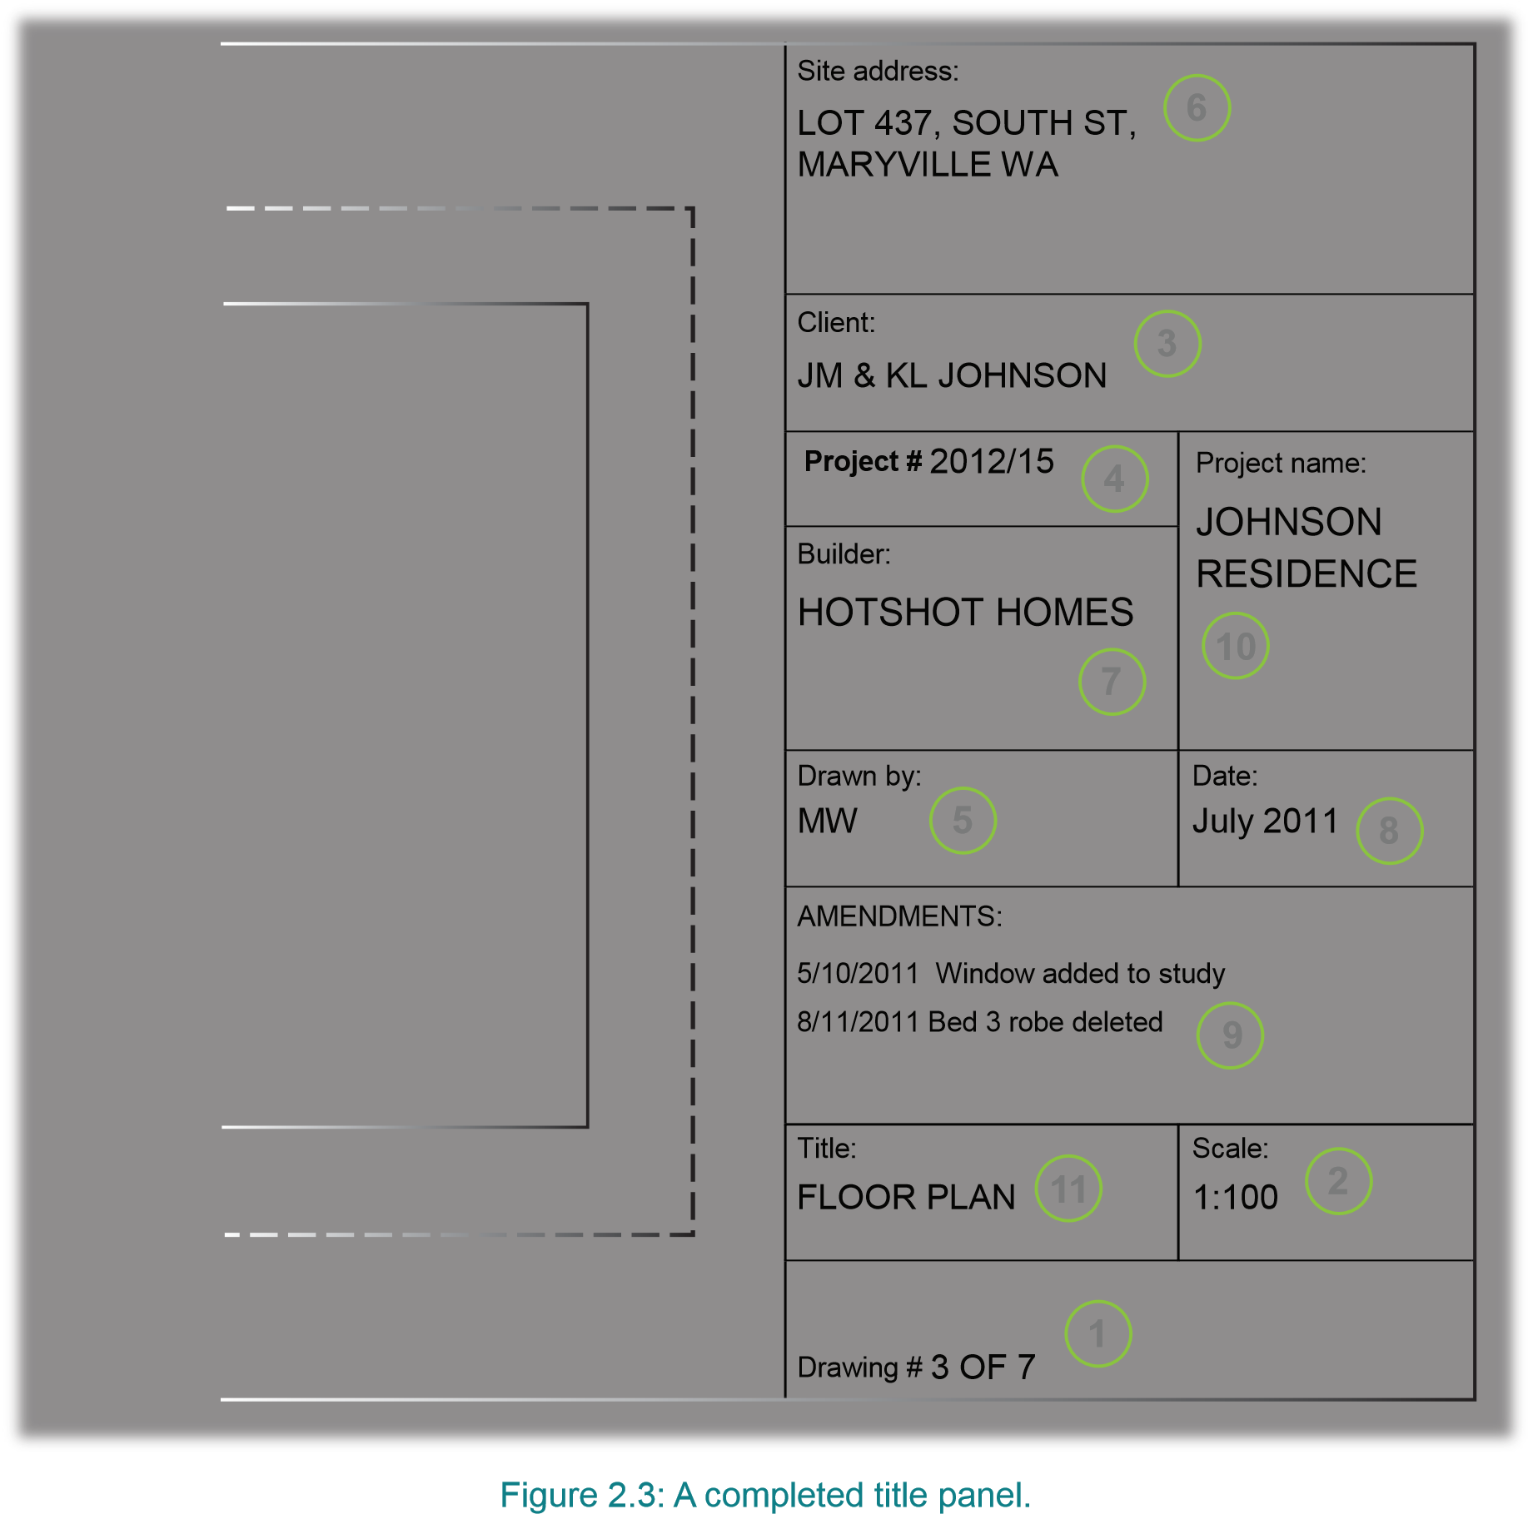

AMENDMENTS
An amendment is a change to a project that is decided after the drawings have been finalized. Amendments are sometimes called revisions. These changes could happen because the client requests them (for example, the client may want an extra window in the study) or because the builder realizes something will work better if it’s done slightly differently. Either way, they need to be shown on paper so that everyone knows about them, they are constructed correctly and there are no arguments later. So obviously it is important to use the latest version of the plans.
If this means that the building will vary from the way it was shown in the original contract documents, a written instruction will be issued by the architect/client and, if necessary, the drawings will be amended (changed) and re-issued.
On an exceptionally large project (such as the Sydney Opera House), there are thousands of drawings required and it is a full-time job for a site clerk to ensure that everyone receives up-to-date drawings to work from.
Old, out-of-date drawings should be stamped and stored rather than destroyed, in case there is any dispute at a later date.

NOTES PANEL
Some drawings have ‘Notes’ as well as a title panel. The information in this panel is important and must not be overlooked.

Notes
Verandah posts to have
12
× 12 chamfer.
Downpipe locations
may be varied as
necessary.
Letterbox may be
positioned either side of
the driveway.
Notes
Veranda posts to have
12
× 12 chamfers.
Downpipe locations
may be varied as
necessary.
Letterbox may be
positioned either side of
the driveway.
A simple drawing sheet with a notes panel.

ABBREVIATIONS AND SYMBOLS
Abbreviations
Abbreviations can be created in different ways. In some cases, the word is shortened. For example, “ENS” for ensuite and “CPBD” for a cupboard.
In other cases, initials are used. For example, “WIR” for walk-in-robe and “WC” for water closet (toilet).
There might be several recognized abbreviations for the same thing. For example, “brickwork” may be shortened to BRK, BWK, or just BK.

Symbols
Like abbreviations, symbols are used instead of words on drawings to save space. There are a lot of them, but they’re standardized (drawn the same way) to avoid confusion, so don’t worry. Some of them look a lot like what they represent.
For example, the symbol:

 indicates a hotplate in the kitchen.

As mentioned in Section 1, some drawings have a legend to indicate what the symbols used on the drawing mean.
The legend shown in Figure 5.1 is from a site plan. Without this legend, the symbols on the drawing could be misinterpreted.
Electrical, hydraulic, and engineering drawings commonly have legends on them.
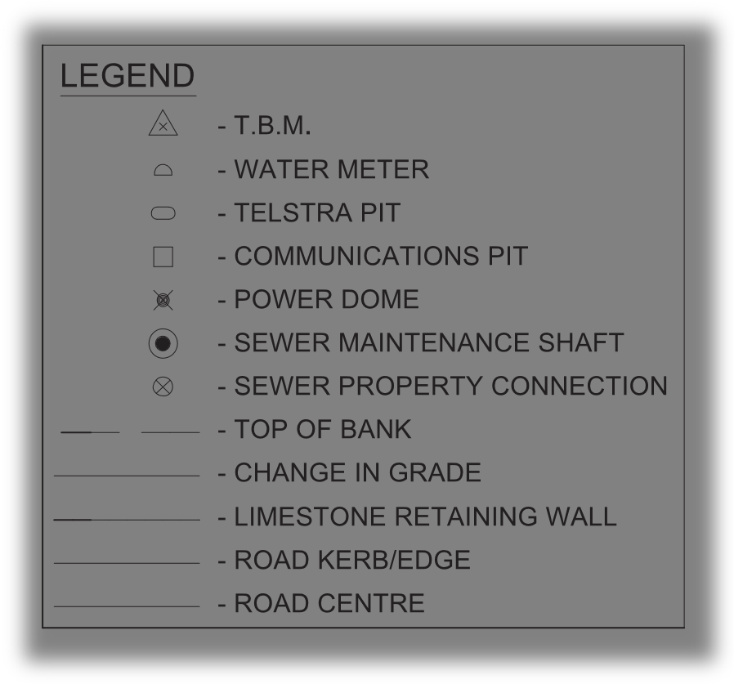
A legend from a site plan showing several symbols and their meanings.

SPECIFICATION
A specification is a written description of the building to be constructed. It supplements the information on the drawings, and, like the drawings, it is a legal part of the contract between the client and the builder. A specification might only be a few pages long for a small project such as an addition to a house, or it might be a multi-volume set of bound books for a big project such as a shopping mall or high-rise building. For a large commercial or industrial project, there may be a specification for the architectural features, and additional specifications for the plumbing, electrical and mechanical requirements of the job. For house construction, one specification booklet is usually sufficient

THE PURPOSE OF A SPECIFICATION
Drawings are the best way to convey most of the information required for a building project, but a specification is needed to explain anything that cannot be included clearly in the drawings. Specifications are commonly used to communicate the following.
- Fixture and fittings to be used, where things like dimensions, color, or model number are important – for example ‘Acme ‘De Luxe clawfoot bath, 1675mm, white’.

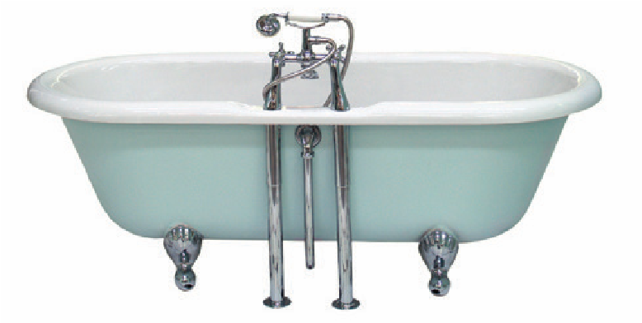

- To provide instructions to the builder or tradespeople for how something is to be done. For example, drawings might show that internal walls are to have a plaster finish, but it is the specification that tells the plasterer how – ‘bring walls to a reasonable flat surface by the application of a cement render float coat while the plaster is setting.’

- To provide instructions to the builder about things that may not be part of the finished building but that nevertheless need to happen during the project – for example, safety barriers, disposal of rubbish or protection, or adjoining properties.

Specifications usually include a clause about making good any damage to footpaths, fences, and any other amenities in the vicinity of the project.
There will also be a clause that deals with the general quality of the materials and workmanship to be used. This usually reads something like:

LAYOUT
The specification (or ‘speci’) for a house is divided into sections (like short chapters) that each deal with a specific trade that will be involved in the project. The sections are usually arranged in the same order that the job will be done in – starting with the excavator, concreter, and bricklayer through to painter, floor coverer, and landscaper at the end.
Each section may contain detailed descriptions specific to that job or it may just contain general instructions about workmanship, quality, and so on. In that case, it will refer to a schedule at the end of the specification. The schedule will have details for a particular job, for example, sizes of skirtings, paint finishes, types of doors, the brand of the stove, color of the bath, and so on.
A section called ‘preliminaries’ at the start of the specification deals with general things, such as the extent of the work, temporary services, the job sign, site sheds and toilets, temporary fences or hoardings, and access for the client during construction.
In project-home building – where the same model is built over and over for different clients – they may use a standard specification and add to that an addendum that includes the selections and specific details for each client.

CHANGES
Sometimes changes, called amendments, might be made to the specification. Amendments could relate, for example, to changes to materials or products used or methods of carrying out specified work. They should be marked so that everyone needs to notice them. Amendments usually have to be signed or initialed by both the builder and the client to show they both agree.

On rare occasions, the specification may conflict with the drawings. For example, the specification may call for the front door to have a glass panel in the top half, yet the elevation may show no glass in the door. In this case, the builder should contact the architect or client and ask for clarification.

CONSTRUCT TIMBER ROOF STRUCTURES

WHAT IS A ROOF?
The roof is the covering on the uppermost part of a building. A roof protects the building and its content from the effect of weather.
In most countries, a roof protects primarily against rain. Depending upon the nature of the building, the roof also protects against heat, against sunlight, against cold and against wind.
A residential building in the tropics is designed with steep roof pitch and wide eaves to keep out the rain.

DESIGN CONSIDERATIONS FOR TIMBER ROOF STRUCTURES
Load Calculation and Analysis
Designing a timber roof structure begins with a thorough analysis of the loads it will be subjected to, including dead loads (weight of the roof itself), live loads (snow, wind, occupancy), and environmental factors. Structural engineers utilize advanced software and calculation methods to determine the optimal size, spacing, and configuration of timber members to ensure structural integrity and safety.

Structural Design Principles
Timber roof structures can be designed using various structural systems, including trusses, beams, arches, and shells, each offering unique advantages in terms of span capability, aesthetic appeal, and construction complexity. Design principles such as equilibrium, stability, and load distribution govern the arrangement of timber elements to resist applied loads and maintain structural equilibrium.

TYPES OF TIMBER ROOF
Timber roof structures encompass a wide range of architectural forms, from simple pitched roofs to complex curved shells. Common types of timber roof structures include:
- Gable roof
- Hip roof
- Shed roof
- Dutch roof
- Gambrel roof
- Winged roof

Gable roofs
Gable roofs are a common type of roof design in residential homes. They consist of two sloping sides at a central ridge, a peak or a gable. This roof design is straightforward, making it a popular choice for homeowners. One of the main advantages of gable roofs is that they allow for ample ventilation and light in the attic space, which can help reduce heat buildup and prevent moisture damage.
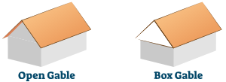

Gambrel Roofs
A gambrel roof, a barn or Dutch roof, is a distinctive design with two slopes on each side. This roof design is commonly found in homes and buildings with a traditional or colonial architectural style, but it can also be seen in other styles. The Gambrel roof has two slopes on each side, with the lower slope steeper than the upper slope. This design allows additional living or storage space in the attic, as the steeper, more downward slope provides ample headroom. Additionally, the Gambrel roof helps to shed rain, snow, and other weather elements, reducing the risk of water damage
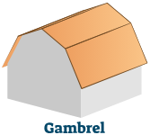

Hip Roofs
Hip roofs are a type of roof design characterized by four sloping sides at the ridge or hip. This roof style is characterized by clean lines, symmetry, and stability, making it a popular choice for homes and buildings in various architectural styles. One of the main advantages of hip roofs is their stability. The design provides equal support to all four sides, which helps distribute the roof's weight evenly and reduces the risk of structural damage from high winds, heavy rainfall, or snow accumulation. The hip ridge also helps prevent water from seeping into the attic space, reducing the risk of moisture damage and mould growth.
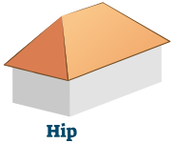

Hip And Valley Roofs
A hip and valley roof is a complex design characterized by sloping sides converging at a ridge or hip, forming valleys between them. This roof design is commonly found in homes and buildings with a traditional or colonial architectural style, but it can also be seen in other building styles. The hip and valley roof consists of sloping sides that converge at a ridge or hip, forming valleys between the sides. This design helps to shed rain and snow, reducing the risk of water damage. The hip and valley roof also provides ample headroom in the attic or upper level, as the ridges or hips are typically higher than other roof designs.
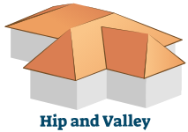

Skillion roofs
Skillion roofs, also known as shed roofs, are a type of roof design characterized by a single sloping surface that runs from one wall of the building to the other. This simple design is often used for smaller structures, such as sheds, garages, annexes, and modern and contemporary architectural styles. One of the main advantages of skillion roofs is their simplicity. The design of the roof is straightforward and requires minimal structural support, making it a cost-effective and efficient option for many building projects. Additionally, the single-sloping surface of the roof provides ample headroom and clearance for the interior space, making it a practical choice for structures where headroom is a concern.

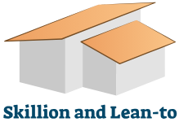

Butterfly roofs
Butterfly roofs, also known as V-roofs or split gable roofs, are a type of roof design characterized by two slopes that descend from the center, creating a V-shaped appearance. This design is commonly used in modern and contemporary architecture and is often associated with clean, minimalist lines and a focus on functionality. The design of butterfly roofs provides several benefits, including increased natural light and ventilation in the interior space. The roof design also helps to channel rainwater and snowmelt away from the building, reducing the risk of leaks and damage. Additionally, the roof design can provide ample attic space, making it an ideal option for homes with limited living space.
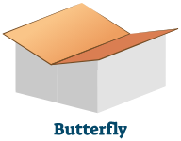

Dutch Gable roof
A Dutch Gable roof, also known as a Dutch Hip roof, is a unique hybrid design that combines elements of both gable and hip roofs. The Dutch Gable roof features two sloping sides that meet at the center ridge, much like a traditional gable roof. However, the gable ends of the roof extend upward, creating a hip-like appearance, with a gently sloping roof that extends to the sides. This design provides the strength and stability of a hip roof with the added aesthetic appeal of a gable 2roof.
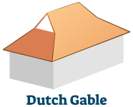

Mansard roof
A mansard roof, also known as a French roof or curb roof, is a distinctive roof design characterized by its steep slope and flat top. It is named after the French architect François Mansart, who popularized the design in the 17th century. Mansard roofs are commonly found in homes and buildings with a French or Second Empire architectural style but can also be seen in other building styles. The Mansard roof is unique in that it has four sides, each with a different slope. The lower two sides of the roof have a steep pitch, while the upper two sides are nearly flat. This design allows for additional living or storage space in the attic, as the flat top provides ample headroom. Additionally, the steep slope of the lower sides helps to shed rain, snow, and other weather elements, reducing the risk of water damage.
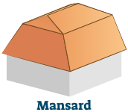

Pyramid roof
A pyramid roof is a simple and elegant design with a triangular shape. It is typically used for small structures such as gazebos or pavilions and is often seen in park settings or other outdoor areas. The pyramid roof is a popular choice for its timeless design, as well as its durability and weather resistance. The pyramid roof is constructed using four triangular sides that converge at a single point at the top. This design provides: A stable and balanced structure. Allowing the roof to withstand wind. Rain. Other weather elements. The triangular shape of the roof also allows rain and snow to run off, reducing the risk of water damage quickly.


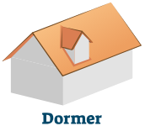
Dormer roof
A dormer is a roof design that projects vertically from the sloping roof of a building and typically contains windows or other architectural features. This design adds space and natural light to an attic or upper level and can also enhance the building's architectural style.

Flat roof
A flat roof is designed with a horizontal surface with a minimal slope. It is commonly found in commercial and industrial buildings, but it can also be found in residential homes and buildings with a modern or minimalist architectural style.
The flat roof design provides many benefits, including ample, usable space on the roof, a simple and low-cost construction method, and a low-profile appearance that can complement certain building styles. However, flat roofs are more susceptible to water damage and leaks, as the water has no natural way to drain off the roof. To mitigate this risk, flat roofs are typically constructed with a slight slope to ensure proper drainage and waterproofing materials are used to prevent leaks.

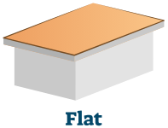

MEMBERS THAT MAKE UP THE ROOF STRUCTURES
Barge: Edge board fixed to overhang and slope to provide finish at gable ends.
Broken Hip: Shortened or flying hip, providing connection between ridges of different heights
Collar Tie: Horizontal tie between alternate pairs of rafters
Creeper Rafter: Shortened rafter, fixed between hip and wall plate. Cripple Creeper Shortened rafter, fixed between hip and valley.
Fascia: Horizontal edge board providing finish to eaves overhang of roof, fixed to ends of rafters.
Hip Rafter: Sloping member forming junction of roof surfaces, fixed between external corners and end of ridge.
Jack Rafter: Central full-size rafter, fitted between wall plate and end of ridge on hip end.
Outrigger: Trimming member fixed to second last rafter and through end rafter to form overhang at gable end.
Purlin Struts: Angled or vertical struts supporting under purlin and roof, fixed between wall plate and under purlin.
Rafter: Sloping member of frame forming roof surface, fixed between wall plate and ridge.
Ridge: Horizontal beam, providing top end framing connection of rafters and hip/valley rafter.
Ridge Brace: Angled timber fixed between wall plate and ridge to maintain plumb end.
Ridge Prop: Vertical prop to support ridge, fixed between wall plate and ridge
Roof Battens: Horizontal timbers placed on flat, across rafters at designed spacing to form fixing for roof material
Strutting Beam: Beam introduced in ceiling structure to provide strutting support to roof/under purlins
Under Purlin: Horizontal member providing lateral support to rafters, to reduce effective span of rafter.
Valley Creeper: Shortened rafter, fixed between valley and ridge.
Valley Rafter: Sloping member forming junction between roof surfaces, fixed between internal corner and ridge intersection or junction of ridge and hip.

The general method of fixing members in a roof structure is by skew nailing using 75mm nails. In some situations, longer nails, bolts, and/or metal connectors are used to provide more secure fixing, particularly associated with strutting support and in high wind areas.

CONSTRUCTION PROCESS OF TIMBER ROOF STRUCTURES
Pre-construction Planning
Before commencing construction, careful planning is essential to ensure the success of a timber roof project. This involves obtaining necessary permits, conducting site surveys, coordinating with architects and engineers, and developing detailed construction plans and schedules.

Timber Selection and Preparation
Timber selection is a critical aspect of roof construction, with factors such as species, grade, moisture content, and size influencing structural performance and durability. Timber components are typically sourced from sustainably managed forests and treated to enhance strength and resistance to decay, insects, and fire.

Assembly Techniques
Timber roof structures are assembled using a combination of traditional joinery methods and modern construction techniques. Skilled craftsmen utilize mortise-and-tenon joints, dovetails, lap joints, and metal fasteners to connect timber members securely. Precision and attention to detail are paramount to ensure structural integrity and aesthetic quality.

Roofing Materials and Finishes
Once the timber structure is in place, roofing materials such as shingles, tiles, metal sheets, or membrane systems are installed to provide weatherproofing and thermal insulation. Finishing touches such as fascia boards, soffits, and gutters enhance the functionality and aesthetics of the roof, completing the construction process.

ADVANTAGES AND CHALLENGES OF TIMBER ROOF STRUCTURES
Sustainability and Environmental Impact
One of the primary advantages of timber roof structures is their sustainability. Timber is a renewable resource that sequesters carbon dioxide during growth, making it an environmentally friendly alternative to non-renewable building materials. Additionally, timber construction requires less energy and generates fewer greenhouse gas emissions compared to steel or concrete.

Cost-effectiveness
Timber roof structures are often more cost-effective than alternative materials, particularly in regions where timber resources are abundant. The lightweight nature of timber reduces transportation costs and construction time, leading to overall savings in project expenses. Additionally, timber's versatility allows for efficient prefabrication and assembly, further reducing labor costs.

Durability and Maintenance
Properly treated and maintained timber roof structures can exhibit excellent durability, with lifespans comparable to or exceeding those of steel or concrete. Regular inspections, repairs, and protective treatments are necessary to prevent decay, insect infestation, and weathering. However, compared to other materials, timber may require more frequent maintenance to ensure long-term performance.

Fire Resistance and Safety
While timber is combustible, modern fire-retardant treatments can enhance its fire resistance and safety in roof construction. Building codes and regulations specify fire protection measures such as sprinkler systems, fire barriers, and compartmentalization to mitigate fire risks in timber structures. Proper design, construction, and maintenance practices are essential for ensuring occupant safety.

FUTURE TRENDS AND INNOVATIONS IN TIMBER ROOF CONSTRUCTION
As the construction industry embraces sustainable practices and explores new materials and technologies, timber roof construction is poised to evolve further. Emerging trends such as mass timber construction, digital fabrication, robotic assembly, and biophilic design principles are reshaping the landscape of timber architecture, offering exciting possibilities for future roof structures that blend aesthetics, performance, and environmental stewardship.

ERECT TIMBER ROOF TRUSSES

WHATE ARE TIMBER ROOF TRUSSES?
A truss is a joint-framed structure designed with a triangular pattern that can sustain vertical, horizontal or inclined loads. It consists of straight interconnected structural elements such as top chords, bottom chords, internal web members and steel connector plates, which are joined at the nodes.
The truss system supports the loadings on the roof throughout the structure, and the external forces and reactions at the supports are applied at the nodes. Steel roof trusses and timber roof trusses are commonly used to support roofs in various structures such as auditoriums, stadiums, cinema halls, airports, railways, and stations.

TYPES OF ROOF TRUSSES
There are different types of roof trusses. Some of them are as follows:
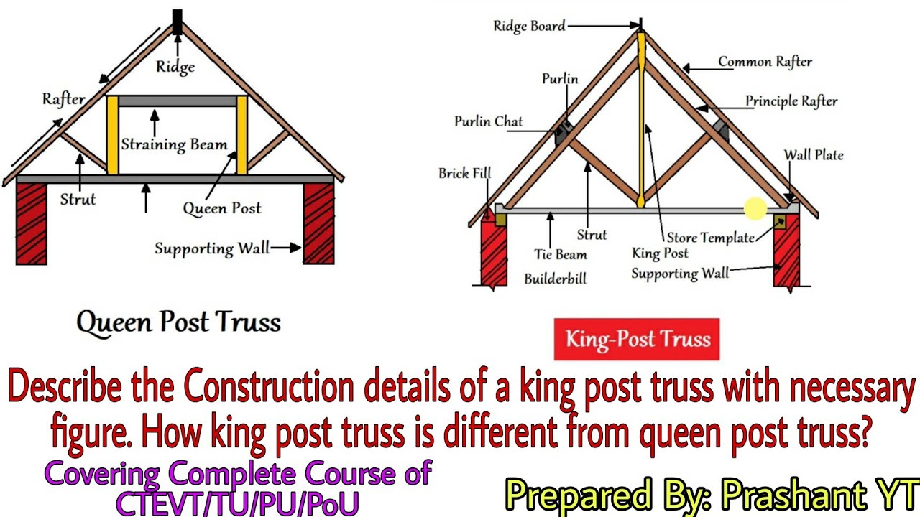
King Post Roof Trusses
The main vertical post used in this type of roof truss is in tension force to support a beam beneath from a truss apex. This truss typically spans up to 8 metres, making it ideal for a variety of house types, particularly smaller ones.

Queen Post Roof Trusses

These types of roof trusses are completely dependable, simple, and adaptable, and they can be used at any random location. Queen Post roof trusses have a span of about 10 m and a simple design that makes them suitable for a wide range of foundations.

Howe Roof Trusses
The Howe truss is a type of truss with upper and lower members made of steel, wood, or both. This truss is notable for one feature: it has an exceptionally wide span that can stretch anywhere from 6 to 30 m. These types of roof trusses are extremely useful for a wide range of project types.
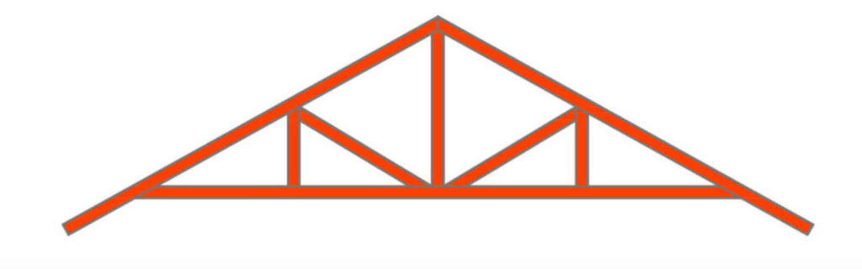

Pratt Roof Trusses
The pratt truss is the most common steel truss because it is extremely efficient. It has vertical and diagonal members that slope down to the centre. These types of roof trusses can have span lengths ranging from 6 to 10 metres.
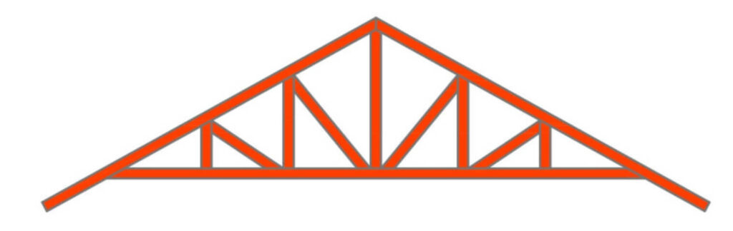

Fan Roof Trusses
A simple steel design is used in these types of roof trusses. This type of truss is used in most projects with a span of 10 to 15 metres.
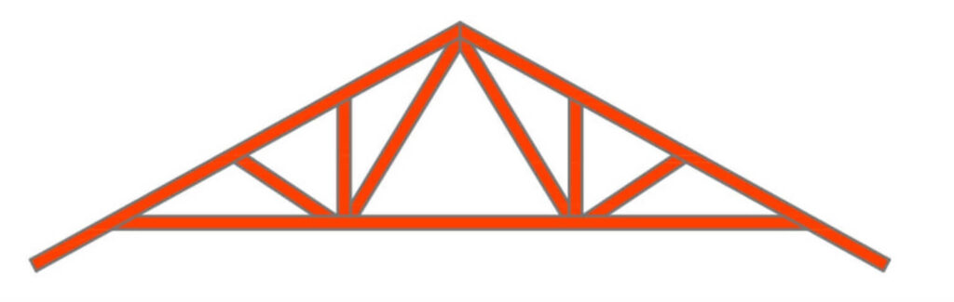

Quadrangular Roof Trusses
Quadrangular trusses are roof trusses with parallel chords and web members organised in compression verticals and tension diagonals. It is most commonly encountered in auditoriums or railway sheds.
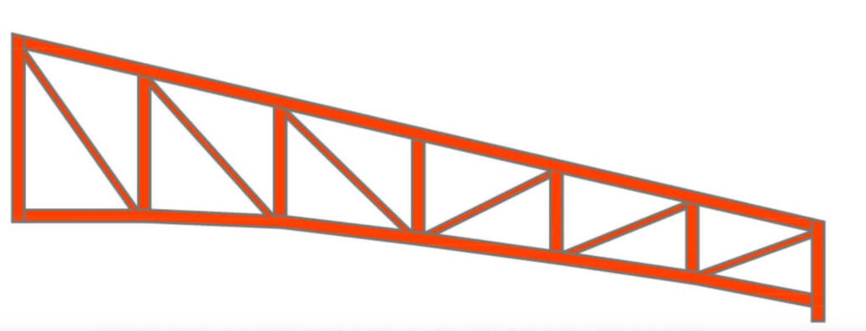

North Light Roof Trusses
North Light Roof Trusses have a diverse array of lattice girders that include support trusses. North light truss is the most common and least expensive type of truss. These roof trusses span 20 to 30 m and can be found in drawing rooms, industrial buildings, and large spaces.
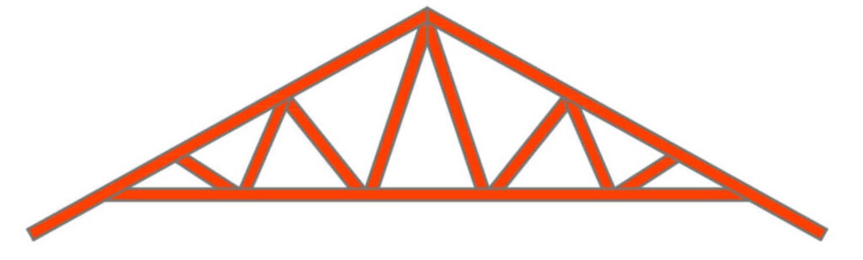

Raised Heel Roof Trusses
Raised Heel Roof Trusses provide a smart way to meet more rigid energy proficiency codes and improve the energy efficiency of the building envelope. Raising the truss improves attic ventilation and leaves enough space for insulation above the outside wall top plates.
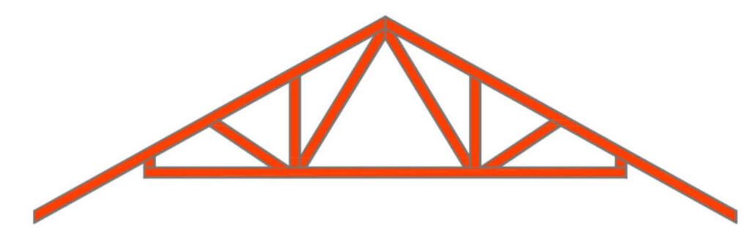

Parallel Chord Roof Trusses
Parallel chord roof trusses are types of roof trusses that are made up of two chords that run parallel to one another and are supported by reinforcing trusses in the middle of the bottom and top chords. Because they create a fume barrier, these types of roof trusses reduce condensation and mould conditions.
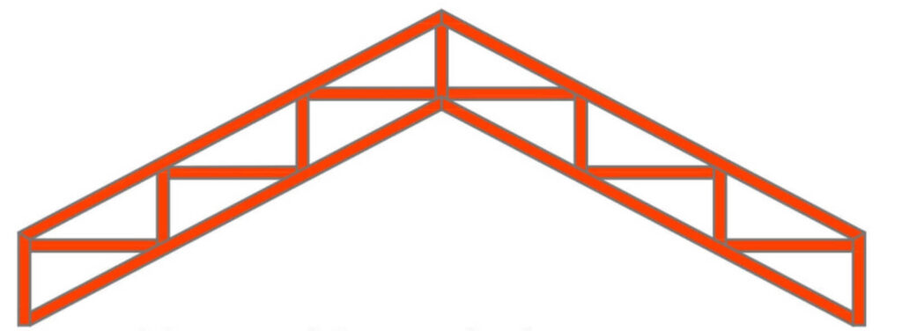

Scissor Roof Trusses
In scissor roof trusses, the bottom chord members cross one another, connecting with the calculated top chords at a point midway along the top chords' length, resembling an opened pair of scissors. A scissor truss can support a vaulted ceiling in the same amount of span length as standard trusses. Cathedral is perhaps the best example of these types of roof trusses.

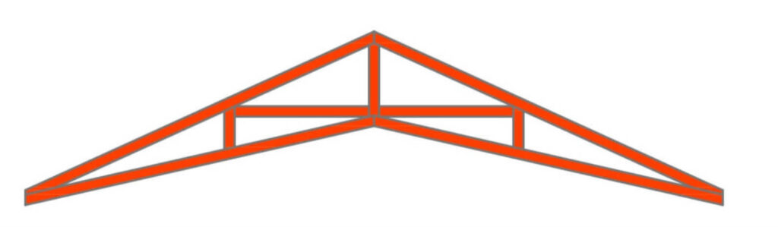

COMPONENTS OF A ROOF TRUSS
The various components of the roof trusses are explained below:
- Apex- It is the highest point where the sloping top chords join together.

- Bearing- It is the structural support of trusses, which is usually accompanied by a timber wall plate.

- Bottom Chords- These are the shortest longitudinal member of the roof trusses

- Cantilever- Cantilevers are part of a structural member which are extended beyond their supports.

- Cantilever Strut- It is a web that connects the chords of the bottom part over the bearing point to the chords of the top part of the cantilevered truss.

- Chord- The main member that forms the outline of a truss and is subjected to enormous axial force and bending moment.

- Clear Span- The horizontal distance between the inside edge of the supports is called the clear span.

- Heel- It is a truss point where the top and bottom chords meet.

- Joint- A joint is the point at which at least one web intersects with a chord.

- Nail Plate- It is the galvanized steel plate that is punched to form a nail design that is needed with the plate and is used to connect the members.

- Node- The point of convergence of at least two members that make up the panels of a truss is referred to as a node.

- Nominal Span- It is the horizontal distance between the outside edges of the supports, which is commonly used as the tie beam length.

- Overhang- The extension of a truss's top chord past the bearing support is referred to as the overhang.
- Panel- It is a truss segment with two adjacent joints or nodes.

- Plumb Cut- The vertical slice to the end of the top chord to allow for vertical installation of the gutter or fascia.

- Splice Point- The splice between the top and bottom cords is the splice point.

- Square Cut- The Square cuts are perpendicular to the chord's edge.

- Stub End- A truss type formed by truncating a typical triangular truss.

- Top Chord or Rafter- A top chord, also known as a rafter, is a horizontal member that supports the upper edges of a truss.

- Web- The members that connect the bottom and top chords to form a triangular shape are the webs of roof trusses.

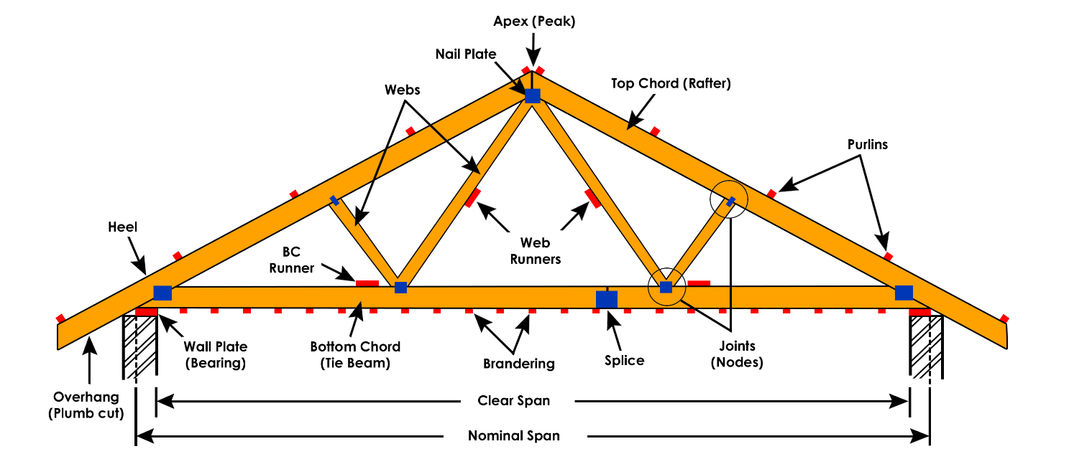

FUNCTIONS OF ROOF TRUSSES
A roof over one's head is a basic human need that we've evolved through hundreds of years of architectural ingenuity. Since the beginning of thatched roofs with straw and reeds, the roofing system has gone through an emotional transformation. When a roof truss is installed, it helps to protect the exposed roof from damage. Because the roof is the first line of defence against environmental elements, it must be protected.
Its function is to shade and protect the home from the sun, rain and other environmental attributes. The roof trusses are complex architectural components that serve as the basic support for a roofing system. The major function of the roof trusses is to act as the major load-bearing element of the roof structure and to transfer the loads to the main support

DESIGN CONSIDERATIONS
Designing timber roof trusses requires careful consideration of several factors, including:
- Roof Load: Calculating the anticipated load that the trusses will bear, including dead loads (roofing materials, insulation) and live loads (snow, wind).

- Span and Pitch: Determining the span of the roof and the desired pitch to optimize structural integrity and drainage.

- Truss Configuration: Selecting the appropriate truss configuration based on architectural requirements and load distribution.

- Support Conditions: Ensuring proper support conditions at the truss bearings and connections with the building's walls.

- Safety Factors: Incorporating safety factors to account for uncertainties in loads and material properties.

MATERIALS USED IN TIMBER TRUSSES
Timber trusses are typically constructed using various types of wood, including:
- Softwood: Commonly used softwoods include pine, spruce, and fir, prized for their affordability and availability.
- Hardwood: Hardwoods like oak and maple may be used for specialized applications where greater strength or aesthetic appeal is desired.

- Engineered Wood Products: Laminated veneer lumber (LVL) and glued laminated timber (glulam) offer enhanced strength and dimensional stability, suitable for long-span trusses.
Metal plates or fasteners are used to join timber members in truss construction, providing reliable connections while facilitating efficient assembly on-site.

CONSTRUCTION PROCESS
The construction of erect timber roof trusses typically involves the following steps:
- Design and Engineering: Trusses are designed by structural engineers to meet specific load and design requirements.

- Material Procurement: Timber members and metal connectors are sourced according to the design specifications.

- Fabrication: Timber members are cut to size and assembled into truss components in a controlled factory environment.

- Transportation: Completed trusses are transported to the construction site using specialized vehicles or trailers.

- Installation: Trusses are lifted into position using cranes or other lifting equipment and secured to the building's walls.

- Bracing and Sheathing: Trusses are braced to maintain stability during construction, and roof sheathing is installed to provide a base for roofing materials.

- Roofing: Roofing materials such as shingles or metal panels are applied to complete the roof assembly.

SAFETY MEASURES
Safety is paramount in the construction and installation of timber roof trusses. Key safety measures include:
Training and Certification: Workers involved in truss installation should be properly trained and certified in construction safety procedures.
Fall Protection: Adequate fall protection systems, such as guardrails or personal fall arrest systems, should be used when working at heights.
Equipment Inspection: Cranes, hoists, and other lifting equipment should be inspected regularly to ensure safe operation.
Stability Checks: Trusses should be braced and stabilized during installation to prevent collapse or shifting.
Weather Awareness: Work should be halted during adverse weather conditions, such as high winds or lightning storms, to prevent accidents.

ADVANTAGES AND DISADVANTAGES
Advantages
- Cost-Effective: Erect timber roof trusses are often more affordable than alternative roofing systems, reducing overall construction costs.
- Speed of Construction: Pre-fabricated trusses can be quickly installed, accelerating the construction timeline and reducing labor expenses.
- Design Flexibility: Timber trusses can accommodate a wide range of architectural styles and roof configurations, offering flexibility in design.
- Strength and Durability: Timber trusses provide reliable structural support and have proven durability when properly maintained.

Disadvantages:
- Limited Span: Timber trusses have limitations on span length compared to steel or concrete alternatives, requiring additional support for longer spans.
- Maintenance Requirements: Timber trusses may require periodic maintenance, such as inspection for wood rot or pest infestation, to ensure longevity.
- Fire Risk: Wood is combustible, posing a fire risk if not adequately protected with fire-resistant coatings or sprinkler systems.

MAINTENANCE AND CARE
To ensure the longevity and performance of timber roof trusses, regular maintenance and care are essential. Maintenance tasks may include:
Inspection: Regular inspections for signs of wood decay, insect damage, or structural issues can identify problems early.
Repairs: Prompt repair of damaged or deteriorated timber members can prevent further structural degradation.
Treatment: Applying preservative treatments or coatings can protect timber trusses from moisture, fungi, and insect infestation.
Cleaning: Keeping trusses free of debris and vegetation can prevent moisture buildup and reduce the risk of decay.

Environmental Considerations
Timber roof trusses offer several environmental benefits compared to alternative construction materials:
Renewable Resource: Wood is a renewable resource that can be sustainably harvested and replenished over time.
Carbon Sequestration: Timber products store carbon absorbed from the atmosphere during tree growth, reducing greenhouse gas emissions.
Energy Efficiency: Wood has excellent thermal insulation properties, contributing to energy-efficient building design.
Biodegradability: At the end of its life cycle, timber can be recycled or disposed of in an environmentally friendly manner.

INSTALL SHEETING AND CLADDING ROOFING MATERIALS

ROOFING MATERIALS
Roofing serves as a critical component of building construction, safeguarding occupants and assets from weather elements such as rain, snow, wind, and sunlight. While traditional roofing materials like clay tiles and slate have been prevalent for centuries, modern advancements have introduced a wide array of sheeting and cladding options, offering improved performance, durability, and design versatility.
Roofing material is the outermost layer on the roof of a building, sometimes self-supporting, but generally supported by an underlying structure. A building’s roofing material provides shelter from the natural elements, an insulation against heat and cold. The outer layer of a roof shows great variation dependent upon availability of material, and the nature of the supporting structure.

TYPES OF SHEETING AND CLADDING ROOFING MATERIALS
Sheeting and cladding roofing materials encompass a diverse range of options, each with its unique characteristics and applications. Metal sheeting, asphalt shingles, fiber cement panels, polycarbonate panels, PVC membranes, and composite materials are among the most commonly used materials in contemporary roofing systems.

Asphalt shingle
Asphalt shingles, also known as composite shingles, are the most common type of roofing materials. Found in 80% of homes, these shingles comprise fiberglass or cellulose mat, asphalt, and mineral granules. Asphalt shingle roofs come in a variety of colors and are a cost-effective replacement solution.
Asphalt shingles last approximately 20 years and work for all climates. If you live in a region prone to icy conditions and hail, consider upgrading to an impact-resistant variety. Specially treated algae-resistant varieties are also available for subtropical areas

Metal Roofing
Contrary to popular belief, metal roofs are not more prone to lightning strikes. Metal roofing is a broad category covering a range of materials and styles. This type of roofing can be an affordable option with a high return on investment (ROI) depending on the metal.
Metals like aluminum, zinc, tin, and steel are cost-effective and low-maintenance options, while copper offers a unique appearance for the high-end metal roof. Metal roofs last between 40 to 80 years and require very little maintenance.

Slate Roofing
Slate is one of the most durable roofing materials, but it comes with a high price tag. Often found in luxury homes, these roofs last anywhere from 60 to 150 years and can withstand extreme temperature fluctuations, high winds, and hail.
Also known as shale roofing, the thin sheets of actual stone are fire-resistant, making the material an ideal choice for dry regions.

Clay Tiles
Clay tiles date back 5,000 years, making them one of the oldest roofing materials. Similar to slate roofing, clay tiles will last over 100 years. These tiles are ideal for tropical climates and are common in Southern California and Florida.
Clay tiles can withstand extremely high winds and constant salt exposure. Many clay types darken with age. Tiles come in four dominant styles: mission, interlocking, French, and Spanish to fit any design aesthetic.

PRE-INSTALLATION CONSIDERATIONS
Before embarking on a roofing project, it is essential to conduct a thorough assessment of the existing roof structure and substrate. Factors such as roof design, pitch, load-bearing capacity, and insulation requirements must be carefully evaluated to ensure compatibility with the selected sheeting and cladding materials.
Additionally, compliance with local building codes, zoning regulations, and environmental standards is paramount to avoid potential legal liabilities and ensure the safety and integrity of the structure. Climate and environmental factors, including wind loads, snow loads, rainfall intensity, and solar exposure, should also inform material selection and installation practices.
Furthermore, implementing appropriate safety precautions and protocols is essential to mitigate the risks associated with working at heights and handling heavy machinery and materials. Adequate training, supervision, and use of personal protective equipment (PPE) are imperative to prevent accidents and injuries on the job site.

TOOLS AND EQUIPMENT
Installing sheeting and cladding roofing materials requires a variety of specialized tools and equipment to ensure precision and efficiency. Basic tools such as hammers, screwdrivers, tape measures, and utility knives are essential for cutting, fastening, and shaping roofing components.
Moreover, power tools such as drills, saws, and pneumatic nail guns can expedite the installation process, particularly when working with metal sheeting and composite materials. Safety gear such as hard hats, safety glasses, gloves, and harnesses should be worn at all times to minimize the risk of falls, cuts, and other occupational hazards.
Additionally, machinery and equipment such as cranes, lifts, and scaffolding may be necessary for accessing elevated areas and transporting heavy materials. Proper training and certification are required for operating such equipment to ensure the safety of both workers and bystanders.

Material Selection
Choosing the right roofing material is critical to the long-term performance, durability, and aesthetic appeal of the structure. Factors such as climate, budget, maintenance requirements, and architectural style should be taken into account when selecting sheeting and cladding materials.

Metal sheeting, for example, is highly durable and low-maintenance, making it an ideal choice for regions prone to extreme weather conditions such as hurricanes, hailstorms, and wildfires. Asphalt shingles, on the other hand, offer a cost-effective solution for residential roofing projects with a wide range of colors and styles to choose from.

Fiber cement panels are popular for their versatility, allowing for various textures and finishes to complement different architectural designs. Polycarbonate panels provide natural daylighting and thermal insulation benefits, making them suitable for eco-friendly and energy-efficient buildings.

PVC membranes offer superior flexibility and chemical resistance, making them ideal for flat and low-slope roofs where traditional materials may be impractical. Composite materials combine the aesthetics of natural roofing materials with the durability and performance of synthetic polymers, offering a sustainable and long-lasting roofing solution.

SURFACE PREPARATION
Proper surface preparation is essential to ensure the adhesion and performance of sheeting and cladding roofing materials. Before installation, the roof substrate should be thoroughly inspected for signs of damage, deterioration, or structural deficiencies.
Any existing roofing materials, such as old shingles, tiles, or membrane systems, should be removed to expose the underlying substrate and allow for a clean and level surface. Repairs and reinforcements may be necessary to address any underlying issues such as water damage, rot, or pest infestations.
Once the substrate is exposed, it should be cleaned and primed to remove dirt, debris, and contaminants that could interfere with the bonding of the new roofing materials. Applying a primer or sealant can help improve adhesion and waterproofing while also providing a protective barrier against moisture and corrosion.

INSTALLATION TECHNIQUES
The installation techniques for sheeting and cladding roofing materials vary depending on the type of material being used, as well as the design and configuration of the roof. However, certain principles and best practices apply across different roofing systems to ensure proper alignment, fastening, and weatherproofing.

Metal sheeting roofs, panels are typically installed in overlapping rows starting from the eaves and working upwards towards the ridge. Each panel is secured to the underlying substrate using fasteners such as screws or nails, with overlapping seams sealed using neoprene washers or butyl tape to prevent water infiltration.

Asphalt shingles are installed in overlapping courses, starting from the bottom edge of the roof and progressing upwards towards the peak. Each shingle is nailed in place using galvanized roofing nails, with adhesive strips on the underside to provide additional bonding and weather resistance.

Fiber cement panels are mounted onto the substrate using corrosion-resistant screws or nails, with proper spacing and alignment to accommodate expansion and contraction due to temperature fluctuations. Polycarbonate and PVC panels are secured using special profiles, brackets, or fasteners designed for translucent roofing materials.

Composite materials are installed using similar techniques as natural roofing materials, such as cedar shakes or slate tiles, with interlocking panels or tiles that are nailed or glued in place. Proper flashing and edge details are essential to ensure watertight seals around penetrations, transitions, and perimeter edges.

JOINING AND SEALING
Properly joining and sealing sheeting and cladding elements is critical to preventing water infiltration and ensuring the long-term integrity of the roofing system. Depending on the material and configuration of the roof, various techniques and materials may be used to create watertight seals at seams, joints, and penetrations.
For metal sheeting roofs, overlapping seams are typically sealed using neoprene washers or butyl tape to prevent water infiltration and corrosion. Sealant may also be applied along ridge caps, eaves, and flashing details to create a continuous barrier against moisture intrusion.

Asphalt shingles rely on the overlapping design of individual shingles to create a water-resistant barrier, with adhesive strips on the underside providing additional bonding and weatherproofing. Proper nail placement and sealant application are essential to prevent wind uplift and water penetration at shingle edges and penetrations.

Fiber cement panels are typically joined using tongue-and-groove or lap joints, with sealant applied along the edges to create a watertight seal. Polycarbonate and PVC panels are secured using special profiles and brackets that provide a secure connection while also allowing for thermal expansion and contraction.

Composite materials may feature interlocking panels or tiles that create a seamless appearance while also providing superior weather resistance. Proper flashing and edge details are essential to ensure watertight seals around penetrations, transitions, and perimeter edges.

FLASHING AND EDGING DETAILS
Flashing plays a crucial role in directing water away from vulnerable areas such as roof penetrations, valleys, and transitions where water runoff is concentrated. Properly installed flashing prevents water infiltration and reduces the risk of leaks and water damage to the underlying structure.
Common types of flashing materials include galvanized steel, aluminum, copper, and lead, each offering different levels of durability, corrosion resistance, and cost-effectiveness. Flashing should be installed in a continuous manner, with overlapping seams and sealed joints to create a watertight barrier.
Edge trims and gutter systems are essential components of sheeting and cladding roofing systems, providing a finished appearance while also directing water away from the roof edge and foundation. Properly designed and installed gutter systems help prevent water buildup and erosion while also reducing the risk of moisture-related issues such as mold and mildew growth.

VENTILATION AND INSULATION
Proper ventilation and insulation are essential for maintaining a healthy and energy-efficient roofing system. Adequate ventilation helps regulate temperature and humidity levels in the attic space, reducing the risk of condensation, moisture buildup, and heat-related damage to roofing materials.
Ridge vents, soffit vents, and gable vents are common ventilation options that promote airflow and heat dissipation, preventing excessive heat buildup and prolonging the lifespan of roofing materials. Proper insulation, such as fiberglass batts or spray foam, helps minimize heat loss and energy consumption while also improving indoor comfort and air quality.

Finishing Touches
Once the roofing materials are installed, a final inspection should be conducted to ensure proper alignment, fastening, and weatherproofing. Any loose or damaged components should be repaired or replaced to prevent water infiltration and ensure the long-term integrity of the roofing system.
Regular cleaning and maintenance are essential for preserving the appearance and performance of sheeting and cladding roofing materials. Debris such as leaves, twigs, and dirt should be removed regularly to prevent water buildup and algae growth, while any damaged or worn-out components should be repaired or replaced promptly to prevent further damage.
Enhancing the aesthetics of roofing systems can be achieved through various design elements such as color, texture, and pattern selection. Choosing complementary materials such as trim, fascia, and ridge caps can create a cohesive and visually appealing look that enhances the overall curb appeal of the structure.

TILE A ROOF
WHAT ARE ROOF TILES?
Roof tiles are overlapping tiles designed mainly to keep out precipitation such as rain or snow and are traditionally made from locally available materials such as clay or slate. Later tiles were made from materials such as concrete and plastic.
Roof tiles can be affixed by screws or nails, but in some cases historic designs such as Mangalore tiles utilize interlocking systems that are self-supporting. Tiles typically cover an underlayment system, which seals the roof against water intrusion.

CATEGORIES OF ROOF TILES
There are numerous profiles, or patterns, of roof tile, which can be separated into categories based on their installation and design.

Shingle / flat tiles

One of the simplest designs of roof tile, these are simple overlapping slabs installed in the same manner as traditional shingles, usually held in place by nails or screws at their top. All forms of slate tiles fall into this category. When installed, most of an individual shingle's surface area will be covered by the shingles overlapping it. As a result of this, flat tiles require more tiles to cover a certain area than other patterns of similar size.
These tiles commonly feature a squared base, as is the case with English clay tiles, but in some cases can have a pointed or rounded end, as seen with the beaver-tail tile common in Southern Germany.

Imbrex and tegula
The imbrex and tegula are overlapping tiles that were used by many ancient cultures, including the Greeks, Romans, and Chinese. The tegula is a flat tile laid against the surface of the roof, while the imbrex is a semi-cylindrical tile laid over the joints between tegulae.
In early designs tegula were perfectly flat, however over time they were designed to have ridges along their edges to channel water away from the gaps between tiles.

Mission / Monk and Nun tiles
Similar to the imbrex and tegula design of tile, mission tiles are a semi-cylindrical two-piece tile system, composed of a pan and cover. Unlike the imbrex and tegula both the pan and cover of Mission tile are arched.
Early examples of this profile were created by bending a piece of clay over a worker's thigh, which resulted in the semi-circular curve. This could add a taper to one end of the tile.

Pantiles / S tiles
Pantiles are similar to mission tiles except that they consolidate the pan and cover into a single piece. This allows for greater surface area coverage with fewer tiles, and fewer cracks that could lead to leakage.
These tiles are traditionally formed through an extruder. In addition to the S-shaped Spanish tiles, this category includes the Scandia tiles common to Scandinavia and Northern Europe.

Interlocking tiles
Dating to the 1840s, interlocking tiles are the newest category of roofing tiles and one of the widest ranging in appearance. Their distinguishing feature is the presence of a ridge for interlocking with one another. This allows them to provide a high ratio of roof area to number of tiles used.
Unlike other types of tiles, which can in some cases be produced through a variety of methods, interlocking tiles can only be manufactured on a large scale with a tile press.
In many cases interlocking tile is designed to imitate other patterns of tile, such as flat shingles or pantiles, which can make it difficult to identify from the ground without inspecting an individual tile for a ridge.

INSTALLATION TECHNIQUES

Proper installation is crucial to the performance and longevity of a tile roof.
- The process begins with the preparation of the roof deck, which involves ensuring a smooth, clean, and properly ventilated surface.
- Next, underlayment is installed to provide a secondary barrier against water infiltration.
- Tiles are then laid out according to the manufacturer's specifications, considering factors such as roof pitch, exposure to wind and rain, and aesthetic considerations.
- Nailing and fastening methods vary depending on the type of tile and roof design but generally involve securing the tiles to the roof deck or battens.
- Special attention is paid to areas such as ridges, hips, and valleys, where flashing and waterproofing details are critical to preventing water penetration.
- Properly installed tile roofs can last for decades with minimal maintenance.

ROOFING SYSTEM COMPONENTS
In addition to tiles, a tile roofing system includes various components that work together to provide weather protection, ventilation, and drainage.
- Battens and counter battens are used to support and space the tiles, allowing for airflow and water drainage.
- Eaves, fascias, and soffits are installed to protect the edges of the roof and provide a finished appearance.
- Gutters and downspouts collect rainwater and direct it away from the building to prevent water damage.
- Ventilation systems, such as ridge vents and soffit vents, help regulate temperature and humidity levels in the attic space, reducing the risk of moisture-related problems.
- Skylights and roof penetrations are carefully flashed and sealed to maintain the integrity of the roofing system.

FIX SHINGLES TO ROOFS AND FACADES
Shingles are integral components of building structures, providing protection against environmental elements such as rain, wind, snow, and sunlight. Additionally, they contribute significantly to the aesthetic appeal of both roofs and facades, enhancing the overall visual impression of a building. However, the effectiveness of shingles can diminish over time due to various factors, necessitating timely repairs or replacements to maintain structural integrity and aesthetic appeal.

TYPES OF SHINGLE MATERIALS
Shingles are available in various materials, each with its unique characteristics and suitability for different environments and architectural styles. Common types of shingle materials include
- Asphalt
- Wood
- Metal
- Slate
- Ceramic
Asphalt shingles are the most widely used due to their affordability and durability.
Wood shingles offer a natural aesthetic appeal.
Metal shingles provide excellent longevity and are resistant to fire and pests.
Slate shingles are prized for their elegance and longevity.
Ceramic shingles offer durability and resistance to weathering, making them suitable for various climates.

THE IMPORTANCE OF SHINGLES IN ROOFING AND FACADES
Shingles serve as the first line of defense against environmental elements such as rain, wind, snow, and sunlight. They act as a protective barrier, preventing water infiltration and shielding the underlying structure from moisture damage. Additionally, shingles contribute to the thermal insulation of buildings, helping to maintain comfortable indoor temperatures and reduce energy consumption.
From an aesthetic perspective, shingles play a crucial role in defining the visual character of buildings. They come in a variety of materials, colors, and styles, allowing for customization to suit architectural preferences and design themes. Whether it's the classic elegance of asphalt shingles or the rustic charm of wooden shakes, the choice of shingles can greatly impact the overall look and feel of a structure.
In addition to their functional and aesthetic roles, shingles also contribute to the structural integrity of roofs and facades. Properly installed and maintained shingles help distribute the weight of snow and ice evenly, reducing the risk of structural damage during extreme weather conditions. They also provide additional reinforcement against wind uplift, enhancing the overall stability of the building envelope.

COMMON ISSUES AFFECTING SHINGLES
Despite their durability, shingles can be susceptible to damage from environmental factors, improper installation, age, pests, and structural movements. Weathering, including exposure to sunlight, moisture, and temperature fluctuations, can cause shingles to degrade over time. Improper installation, such as inadequate sealing or fastening, can lead to premature shingle failure. Additionally, as shingles age, they may become brittle and prone to cracking or breaking. Pest infestation, including insects and rodents, can also compromise shingle integrity by nesting or chewing through the material. Furthermore, structural movements, such as settling or shifting of the building foundation, can cause shingles to warp or become dislodged.

ASSESSMENT AND PREPARATION
Before undertaking any shingle repair or replacement work, it is essential to conduct a thorough assessment of the extent of damage and prepare accordingly. This involves inspecting the shingles for signs of wear, damage, or deterioration, as well as identifying any underlying issues such as water damage or pest infestation. Additionally, safety precautions should be taken to prevent accidents or injuries during the repair process. This includes using appropriate personal protective equipment (PPE) such as gloves, safety goggles, and non-slip footwear, as well as securing ladders and scaffolding to prevent falls. Furthermore, gathering the necessary tools and materials, including replacement shingles, nails, adhesives, and sealants, is essential for completing the repair or replacement work effectively.

Repairing Asphalt Shingles
Asphalt shingles are among the most common types of roofing materials due to their affordability, durability, and ease of installation. However, they can be susceptible to damage from weathering, impact, or improper installation. Repairing asphalt shingles typically involves identifying and removing damaged shingles, preparing the underlying surface, and installing new shingles. To repair asphalt shingles, start by inspecting the roof for signs of damage, such as missing, cracked, or curled shingles. Use a pry bar or shingle remover to carefully lift and remove the damaged shingles, taking care not to damage surrounding shingles or the underlying roof deck. Once the damaged shingles have been removed, inspect the underlying surface for any signs of water damage or deterioration. Repair any damaged areas as needed, then install new shingles by sliding them into place and securing them with roofing nails. Finally, seal the edges of the new shingles with roofing cement to prevent water infiltration and ensure a watertight seal.

Restoring Wood Shingles
Wood shingles are valued for their natural aesthetic appeal and insulating properties, but they can be susceptible to damage from moisture, pests, and UV exposure. Repairing wood shingles typically involves repairing split or cracked shingles, treating the wood for longevity, and staining or painting for aesthetic enhancement. To repair wood shingles, start by inspecting the roof for signs of damage, such as split, cracked, or warped shingles. Use a pry bar or hammer to carefully remove any damaged shingles, taking care not to damage surrounding shingles or the underlying roof deck. Once the damaged shingles have been removed, inspect the underlying surface for any signs of water damage or deterioration. Repair any damaged areas as needed, then install new shingles by sliding them into place and securing them with roofing nails. Finally, treat the wood shingles with a wood preservative to protect against moisture, pests, and UV exposure, and stain or paint the shingles as desired to enhance their appearance and prolong their lifespan.

Replacing Metal Shingles
Metal shingles are prized for their durability, longevity, and resistance to fire, pests, and weathering. However, they can be susceptible to damage from impact, corrosion, or improper installation. Repairing metal shingles typically involves identifying and removing damaged shingles, preparing the underlying surface, and installing new shingles. To repair metal shingles, start by inspecting the roof for signs of damage, such as dents, scratches, or corrosion. Use a pry bar or hammer to carefully remove any damaged shingles, taking care not to damage surrounding shingles or the underlying roof deck. Once the damaged shingles have been removed, inspect the underlying surface for any signs of corrosion or deterioration. Repair any damaged areas as needed, then install new shingles by sliding them into place and securing them with roofing nails. Finally, seal the edges of the new shingles with roofing cement to prevent water infiltration and ensure a watertight seal.

Repairing Slate Shingles
Slate shingles are prized for their elegance, durability, and longevity, but they can be susceptible to damage from impact, weathering, or improper installation. Repairing slate shingles typically involves identifying and removing broken shingles, preparing the underlying surface, and installing new shingles. To repair slate shingles, start by inspecting the roof for signs of damage, such as cracked, chipped, or broken shingles. Use a slate ripper or hammer and chisel to carefully remove any damaged shingles, taking care not to damage surrounding shingles or the underlying roof deck. Once the damaged shingles have been removed, inspect the underlying surface for any signs of deterioration or damage. Repair any damaged areas as needed, then install new shingles by sliding them into place and securing them with roofing nails. Finally, seal the edges of the new shingles with roofing cement to prevent water infiltration and ensure a watertight seal.

Facade shingle repairs
In addition to roofs, shingles are often used on building facades to enhance visual appeal and provide protection against the elements. Facade shingles can be made from a variety of materials, including wood, metal, vinyl, and composite materials. Repairing facade shingles typically involves identifying and replacing damaged shingles, as well as ensuring uniformity and aesthetic appeal. To repair facade shingles, start by inspecting the facade for signs of damage, such as cracked, chipped, or missing shingles. Use a pry bar or hammer to carefully remove any damaged shingles, taking care not to damage surrounding shingles or the underlying structure. Once the damaged shingles have been removed, inspect the underlying surface for any signs of deterioration or damage. Repair any damaged areas as needed, then install new shingles by sliding them into place and securing them with appropriate fasteners. Finally, seal the edges of the new shingles with caulk or sealant to prevent water infiltration and ensure a watertight seal.

MAINTENANCE PRACTICES FOR SHINGLE LONGEVITY
In addition to repairing damaged shingles, it is essential to implement regular maintenance practices to prolong the lifespan of shingles and ensure the continued integrity of building structures. This includes conducting regular inspections to identify any signs of damage or deterioration, such as cracked, curled, or missing shingles, as well as addressing any issues promptly to prevent further damage. Additionally, cleaning shingles regularly to remove dirt, debris, and organic matter can help prevent moisture buildup and reduce the risk of mold, mildew, and pest infestation. Furthermore, implementing preventive measures such as installing gutter guards, trimming overhanging branches, and ensuring proper ventilation can help mitigate potential issues and extend the lifespan of shingles.

REPAIR SHEETING AND CLADDING ROOFING MATERIALS

Sheeting and cladding materials play a vital role in modern construction, serving as protective layers for roofs and facades while enhancing the aesthetic appeal of buildings. From metal and polycarbonate sheeting to PVC cladding and wood cladding, these materials offer durability, versatility, and design flexibility. However, despite their resilience, sheeting and cladding are susceptible to wear, damage, and deterioration over time due to various factors. Proper maintenance and timely repairs are essential to ensure the longevity, functionality, and visual appeal of roofing systems.

TYPES OF SHEETING AND CLADDING MATERIALS
Sheeting and cladding materials come in various forms, each with its unique properties and suitability for different applications. Metal sheeting, such as steel or aluminum, offers strength, durability, and resistance to corrosion, making it ideal for roofing and cladding in harsh environments. Polycarbonate sheeting is lightweight, transparent, and impact-resistant, making it suitable for roofing and skylights. Fiberglass sheeting combines strength and flexibility, providing insulation and natural light transmission. PVC cladding is durable, low-maintenance, and available in a range of colors and textures, making it a popular choice for facades. Wood cladding offers natural beauty, warmth, and insulation properties, enhancing the architectural appeal of buildings.

COMMON ISSUES AFFECTING SHEETING AND CLADDING
Despite their durability, sheeting and cladding materials can experience various issues that compromise their integrity and performance. Corrosion and rusting are common concerns with metal sheeting, especially in coastal or industrial areas exposed to moisture and salt air. UV degradation can cause polycarbonate sheeting to become brittle and discolored over time, reducing its transparency and impact resistance. Impact damage from hail, falling debris, or foot traffic can puncture or dent sheeting and cladding materials, leading to leaks and structural weakness. Poor installation practices, such as inadequate fastening or sealing, can result in water infiltration and premature failure. Water leakage can occur due to damaged or deteriorated seals, flashing, or joints, leading to moisture damage and mold growth.

ASSESSMENT AND PREPARATION
Before initiating any repair work on sheeting and cladding materials, a thorough assessment of the extent of damage is essential. This involves inspecting the roofing or cladding system for signs of wear, damage, or deterioration, as well as identifying underlying issues such as water infiltration or structural instability. Safety precautions should be taken to protect workers and occupants from potential hazards, such as falls, electrical hazards, or exposure to hazardous materials. This includes wearing appropriate personal protective equipment (PPE), such as gloves, safety goggles, and respiratory protection, as well as securing ladders and scaffolding to prevent falls. Additionally, gathering the necessary tools and materials, including replacement sheets or cladding, fasteners, sealants, and protective coatings, is essential for completing the repair work effectively.

Repairing Metal Sheeting:
Metal sheeting is widely used in roofing and cladding applications due to its strength, durability, and resistance to corrosion. However, over time, metal sheeting can be susceptible to corrosion, rusting, and mechanical damage. Repairing metal sheeting typically involves identifying and addressing corrosion and rust, cleaning and treating damaged areas, and replacing or repairing sections as needed. To repair metal sheeting, start by inspecting the roof or facade for signs of corrosion and rust, such as discoloration, pitting, or flaking. Use a wire brush or sandpaper to remove loose rust and corrosion, then clean the surface with a mild detergent and water. Apply a rust converter or primer to treat any remaining rust and prevent further corrosion. For small holes or dents, use metal patching compound or epoxy filler to fill and smooth the surface. For larger areas of damage, consider replacing the affected sections with new metal sheeting, ensuring proper sealing and fastening to prevent water infiltration.

Restoring Polycarbonate Sheeting:
Polycarbonate sheeting is valued for its transparency, impact resistance, and versatility, making it ideal for roofing, skylights, and greenhouse applications. However, prolonged exposure to UV radiation can cause polycarbonate sheeting to become brittle, discolored, and prone to cracking. Restoring polycarbonate sheeting typically involves addressing UV degradation, cleaning and polishing the surface, and repairing cracks or holes. To restore polycarbonate sheeting, start by inspecting the surface for signs of UV degradation, such as yellowing, brittleness, or surface crazing. Apply a UV protective coating or film to the surface to block harmful UV radiation and prevent further degradation. Clean the surface with a mild detergent and water to remove dirt, debris, and surface contaminants. Polish the surface with a plastic polish or wax to restore clarity and shine. For cracks or holes, use a polycarbonate repair kit or adhesive to fill and seal the damaged areas, ensuring a watertight seal and structural integrity.

Repairing Fiberglass Sheeting:
Fiberglass sheeting is known for its strength, flexibility, and insulation properties, making it suitable for roofing, cladding, and insulation applications. However, fiberglass sheeting can be prone to cracking, delamination, and water infiltration over time. Repairing fiberglass sheeting typically involves patching damaged areas, reinforcing weak sections, and sealing and waterproofing the surface. To repair fiberglass sheeting, start by cleaning the surface with a mild detergent and water to remove dirt, debris, and surface contaminants. Sand the damaged area with fine-grit sandpaper to roughen the surface and improve adhesion. Apply a fiberglass patch or repair kit to the damaged area, ensuring proper alignment and coverage. Allow the patch to cure fully, then sand the surface smooth and apply a waterproof sealant or coating to prevent water infiltration and further damage.

Maintaining PVC Cladding:
PVC cladding is valued for its durability, low-maintenance, and versatility, making it a popular choice for facades, soffits, and trim. However, PVC cladding can be susceptible to cracking, fading, and warping over time due to exposure to UV radiation and extreme temperatures. Maintaining PVC cladding typically involves cleaning the surface, repairing cracks or tears, and replacing damaged sections as needed. To maintain PVC cladding, start by cleaning the surface with a mild detergent and water to remove dirt, debris, and surface contaminants. Use a soft brush or sponge to scrub the surface gently, then rinse with clean water and allow to dry thoroughly. Inspect the cladding for signs of damage, such as cracks, tears, or warping. Use PVC cement or adhesive to repair small cracks or tears, ensuring a secure bond and watertight seal. For larger areas of damage, consider replacing the affected sections with new PVC cladding, ensuring proper alignment and sealing to prevent water infiltration and maintain structural integrity.

Rehabilitating Wood Cladding
Wood cladding is prized for its natural beauty, warmth, and insulation properties, making it a popular choice for facades, siding, and decking. However, wood cladding can be susceptible to rot, decay, and insect infestation over time, especially if not properly maintained. Rehabilitating wood cladding typically involves addressing rot and decay, repairing cracks or splits, and staining or painting for protection. To rehabilitate wood cladding, start by inspecting the surface for signs of rot, decay, or insect damage. Use a screwdriver or awl to probe the wood and identify soft or spongy areas indicative of rot or decay. Remove any affected areas of wood using a chisel, saw, or wood rot repair kit, ensuring to cut back to solid, healthy wood. Treat the remaining wood with a wood preservative or fungicide to prevent further decay and protect against insect infestation. Repair any cracks or splits in the wood using wood filler or epoxy, ensuring a smooth surface and proper adhesion. Finally, stain or paint the wood cladding as desired to enhance its appearance and protect against moisture, UV radiation, and weathering.

PREVENTIVE MAINTENANCE PRACTICES
In addition to addressing existing issues, preventive maintenance is essential for prolonging the lifespan and performance of sheeting and cladding materials. Regular inspection and cleaning can help identify and address potential issues before they escalate, reducing the need for costly repairs or replacements. Applying protective coatings or sealants can help enhance durability, weather resistance, and UV protection, prolonging the lifespan of sheeting and cladding materials. Addressing issues promptly and proactively can help maintain structural integrity, prevent water infiltration, and ensure the longevity and functionality of roofing systems.

ERECT CEILING FRAMING
Ceiling framing is an essential aspect of building construction, providing structural support and defining the visual appeal of interior spaces. Whether constructing residential homes, commercial buildings, or remodeling projects, the proper erection of ceiling framing is crucial for ensuring structural integrity, functionality, and aesthetic appeal. This essay aims to provide a comprehensive guide to mastering the art of ceiling framing, covering various aspects including fundamentals, types of framing systems, materials, tools, techniques, challenges, safety considerations, maintenance, and future trends. By understanding the principles outlined herein, individuals can execute ceiling framing projects with precision and confidence, achieving superior results in their construction endeavors.

FUNDAMENTALS OF CEILING FRAMING
Ceiling framing refers to the structural framework that supports the ceiling of a building and provides a surface for finishing materials such as drywall, plaster, or ceiling tiles. The primary purpose of ceiling framing is to distribute the weight of the ceiling materials evenly and transfer loads to the building's walls and foundation. Key components of ceiling framing systems include ceiling joists, beams, rafters, trusses, blocking, and bridging, which work together to form a stable and secure structure.

TYPES OF CEILING FRAMING SYSTEMS
Ceiling framing systems can be broadly classified into three main types: conventional framing systems, truss framing systems, and suspended ceiling systems. Conventional framing systems consist of individual members such as joists, beams, and rafters assembled on-site to form a framework for supporting the ceiling. Truss framing systems utilize prefabricated truss components assembled off-site and installed on-site to form a rigid structural framework. Suspended ceiling systems, also known as drop ceilings, consist of lightweight panels suspended from an overhead structure, creating a gap between the panels and the original ceiling surface.

MATERIALS FOR CEILING FRAMING
Ceiling framing materials vary depending on factors such as structural requirements, design preferences, and budget constraints. Common materials used for ceiling framing include wood, metal, and composite materials. Wood framing materials such as dimensional lumber, engineered wood products, and plywood are widely used due to their availability, affordability, and ease of installation. Metal framing materials such as steel and aluminum offer high strength-to-weight ratios, durability, and resistance to fire and pests. Composite framing materials combine wood fibers, plastics, and resins to create lightweight, durable, and moisture-resistant solutions.

TOOLS AND EQUIPMENT FOR CEILING FRAMING
A variety of tools and equipment are used in the erection of ceiling framing, ranging from hand tools to power tools and safety equipment. Hand tools commonly used in ceiling framing include hammers, saws, levels, squares, tape measures, and chisels. Power tools such as drills, nail guns, screw guns, saws, and routers expedite the assembly process and ensure precision and accuracy. Safety equipment such as hard hats, safety goggles, gloves, ear protection, and fall protection gear are essential for preventing accidents and injuries on the job site.

PLANNING AND DESIGN CONSIDERATIONS
Proper planning and design are critical for successful ceiling framing projects, ensuring structural integrity, functionality, and aesthetic appeal. Factors to consider during the planning and design phase include assessing structural requirements, incorporating design preferences, and accounting for HVAC, electrical, and plumbing considerations. Structural requirements such as load-bearing capacities, span lengths, and ceiling heights influence the selection of framing materials and configurations. Design preferences such as architectural style, ceiling profiles, and finishes dictate the overall aesthetics of the space. Integration with HVAC, electrical, and plumbing systems requires careful coordination to ensure compatibility and efficiency.

Erecting Conventional Ceiling Framing
The process of erecting conventional ceiling framing involves marking layout lines, installing ceiling joists, attaching joists to walls and beams, installing blocking and bridging, and adding additional supports as needed. Layout lines are marked on the walls and beams to indicate the positions of ceiling joists and other framing members. Ceiling joists are installed perpendicular to the direction of the walls and beams, spaced at regular intervals to support the ceiling materials. Joists are attached to walls and beams using nails, screws, or joist hangers, ensuring a secure connection. Blocking and bridging are installed between joists to provide additional support, prevent twisting or sagging, and distribute loads evenly. Additional supports such as headers, beams, or posts may be added as needed to accommodate structural requirements or design preferences.

Constructing Truss Ceiling Framing
Truss ceiling framing involves the assembly and installation of prefabricated truss components to form a rigid structural framework. Trusses are designed to span large distances without the need for intermediate supports, making them ideal for wide-open spaces such as great rooms, auditoriums, and commercial buildings. The process of constructing truss ceiling framing includes understanding truss design and function, assembling truss components, installing trusses in position, securing trusses to walls and beams, and bracing trusses for stability. Trusses are typically manufactured off-site and delivered to the job site ready for installation, minimizing on-site labor and construction time. Once in position, trusses are secured to walls and beams using fasteners or connectors, and bracing is added to prevent lateral movement or buckling.

Installing Suspended Ceiling Systems
Suspended ceiling systems, also known as drop ceilings, offer a cost-effective and versatile solution for concealing utilities, improving acoustics, and enhancing aesthetics. The process of installing suspended ceiling systems involves selecting suspension components, attaching suspension tracks to the structure, installing ceiling panels, incorporating lighting and HVAC fixtures, and finishing and detailing the ceiling. Suspension components such as main runners, cross tees, and wall angles are selected based on the desired ceiling height, layout, and configuration. Suspension tracks are attached to the structure using screws or anchors, ensuring a secure and level installation. Ceiling panels are inserted into the suspension tracks, creating a grid pattern that supports the weight of the panels and any additional fixtures. Lighting and HVAC fixtures are integrated into the suspended ceiling system, providing illumination and climate control as needed. Finally, the ceiling is finished and detailed with edge trim, molding, or paint to achieve the desired aesthetic.

COMMON CHALLENGES IN CEILING FRAMING
Ceiling framing projects may encounter various challenges that can impact the quality, efficiency, and safety of the construction process. Common challenges include structural integrity issues such as inadequate support or overloading, alignment and leveling problems such as uneven or sloping surfaces, integration with other building systems such as HVAC, electrical, and plumbing, and material selection and compatibility issues such as mismatched components or poor-quality materials. Addressing these challenges requires careful planning, coordination, and problem-solving skills to ensure successful project outcomes.

SAFETY CONSIDERATIONS IN CEILING FRAMING
Safety is paramount in ceiling framing projects, as they often involve working at heights, handling heavy materials, and using power tools and equipment. Proper safety precautions must be taken to prevent accidents and injuries on the job site. Working at heights requires the use of fall protection equipment such as harnesses, lanyards, and anchor points to prevent falls and mitigate the risk of serious injury. Handling heavy materials such as lumber, metal, and trusses requires proper lifting techniques, team lifting, and the use of mechanical aids such as cranes or hoists to prevent strains and sprains. Using power tools and equipment requires proper training, maintenance, and safety guards to prevent accidents such as cuts, lacerations, and amputations. Personal protective equipment (PPE) such as hard hats, safety goggles, gloves, and hearing protection should be worn at all times to protect against hazards such as falling objects, flying debris, and loud noises.

MAINTENANCE AND REPAIRS OF CEILING FRAMING
Regular inspection and maintenance are essential for preserving the structural integrity and longevity of ceiling framing systems. Inspections should be conducted periodically to identify signs of damage or deterioration such as cracks, sagging, or water stains. Repairs should be addressed promptly to prevent further damage and ensure the safety and stability of the structure. Common maintenance tasks include tightening fasteners, replacing damaged components, reinforcing weak areas, and treating wood framing materials with preservatives or sealants to protect against moisture, pests, and decay. In cases of extensive damage or structural failure, professional assistance may be required to assess the extent of the damage and implement appropriate repairs or reinforcements.

FUTURE TRENDS IN CEILING FRAMING
Advances in materials and technologies are driving innovation in ceiling framing, leading to sustainable and eco-friendly solutions, and integration with smart building systems. Sustainable materials such as engineered wood products, recycled metals, and composite materials are gaining popularity due to their environmental benefits and performance advantages. Eco-friendly practices such as energy-efficient design, renewable energy sources, and green building certifications are becoming increasingly important in ceiling framing projects. Integration with smart building systems such as automated controls, sensors, and monitoring devices allows for real-time monitoring, remote operation, and predictive maintenance, enhancing efficiency, comfort, and sustainability.

REFERENCES

American Society of Heating, Refrigerating and Air-Conditioning Engineers. (2019). ASHRAE Handbook—Fundamentals. ASHRAE.
Asphalt Roofing Manufacturers Association. (2022). Asphalt Shingles: A Homeowner's Guide. https://asphaltroofing.org/homeowners-guide-asphalt-shingles/
Cedar Shake and Shingle Bureau. (2022). Wood Roofing Installation and Maintenance Manual. https://www.cedarbureau.org/publications/
Construction Specifications Institute. (2018). MasterFormat: Master list of numbers and titles for the Construction Industry. Construction Specifications Institute
Metal Roofing Alliance. (2022). Metal Roofing Installation Guide. https://www.metalroofing.com/tools-education/installation-guides/
National Roofing Contractors Association. (2017). NRCA Roofing Manual: Architectural Metal Flashing, Condensation Control and Reroofing. National Roofing Contractors Association.
National Roofing Contractors Association. (2022). Roofing Materials Guide: Shingles. https://www.nrca.net/roofing/NRCA-roofing-manual
Parnell, T. A. (2016). Roofing Construction & Estimating. Craftsman Book Company.
Richardson, M. (Ed.). (2020). Building Construction Handbook. Routledge.
U.S. Green Building Council. (2014). LEED v4 Building Design and Construction. U.S. Green Building Council.
Walker, J. (2015). Roofs: A Guide to the Repair of Historic Roofs. Historic England.
White, J. M. (2018). Manual of Industrial Microbiology and Biotechnology. American Society for Microbiology.

